UN/SCEGHS/19/INF.9
UN/SCETDG/37/INF.21
Committee of Experts on the Transport of Dangerous Goods
and on the Globally Harmonized System of Classification 21 May 2010
and Labelling of Chemicals

Sub-Committee of Experts on the  Transport of Dangerous Goods  Thirty-seventh session  Geneva, 21 – 30 June 2010  Item 3 of the provisional agenda:  Listing, classification and packing | Sub-Committee of Experts on the Globally  Harmonized System of Classification  and Labelling of Chemicals  Nineteenth session  Geneva, 30 June – 2 July 2010  Item 2 (a) of the provisional agenda:  Updating of the third revised edition of the Globally Harmonized System of Classification and Labelling of Chemicals (GHS): Physical hazards
Proposals to update references to ISO standards
Transmitted by the European Industrial Gases Association (EIGA)
Introduction
1. The classification of gas mixtures containing flammable components and the classification of gas mixtures containing oxidising components can be determined according calculation methods described in two ISO standards:
(a) ISO 10156:1996 Gas cylinders-Gases and gas mixtures – Determination of fire potential and oxidising ability for the selection of cylinder valve outlets;
(b) ISO 10156-2:2005 Gas cylinders-Gases and gas mixtures – Part 2: Determination of oxidizing ability of toxic and corrosive gases and gas mixtures.
2. The Orange Book refers:
(a) To ISO 10156 in 2.2.2.1(a)(ii), and in 2.2.3(a) and (d);
(b) To ISO 10156-2 in 2.2.3(d).
3. The Purple Book refers:
(a) To ISO 10156 in 2.2.4.2 , in 2.2.5 and in the Note under 2.4.1, in 2.4.4.1 and 2.4.4.2;
(b) To ISO 10156-2 in the Note under 2.4.1, in 2.4.4.1 and 2.4.4.2.
4. These two standards have been revised by a working group set up by ISO Technical Committee TC58 Gas Cylinders that included experts from Germany, CGA and EIGA. The WG took the opportunity to amalgamate the two standards in one revised standard ISO standard published in April: ISO 10156:2010 Gases and gas mixtures – Determination of fire potential and oxidising ability for the selection of cylinder valve outlets.
5. The revised standard takes into account the new criteria for oxidising gases of 23.5% in the Note of 2.4.1. As a consequence, the section 2.4.4.1 Guidance that refers to the former criteria of 21% should be modified accordingly.
Proposals
Proposal 1 (concerning the reference to ISO 10156:2010)
6. In the Orange Book:
(a) In 2.2.2.1(a)(ii), and in 2.2.3(a) and (d): change ISO 1056:1996 into ISO 10156:2010; and
(b) In 2.2.3(d) delete the reference to ISO 10156-2:2005.
7. In the Purple Book:
(a) In 2.2.4.2 , in 2.2.5 and in the Note under 2.4.1, in 2.4.4.1 and 2.4.4.2): change ISO 1056:1996 into ISO 10156:2010; and
(b) In the Note under 2.4.1, in 2.4.4.1 and 2.4.4.2.delete the reference to ISO 10156-2:2005.
Proposal 2 (concerning the example in 2.4.4.2 Guidance)
8. Replace the current text of 2.4.4.2 with the following text:
"The classification method described in ISO 10156 uses the criterion that a gas mixture should be considered as more oxidising than air if the “Oxidising ¨Power (OP)” of the gas mixture is higher than 0.235 (23.5%).
The OP is calculated as follows:
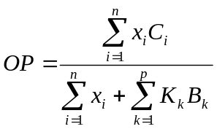
Where:
x_{i} is the molar fraction in mole% of the i:th oxidising gas in the mixture
C_{i} is the coefficient of oxygen equivalency of the i:th oxidising gas in the mixture
K_{k} is the coefficient of equivalency of the inert gas k compared to nitrogen
B_{k} is the molar fraction in mole% of the k:th inert gas in the mixture
is the total number of oxidising gases in the mixture
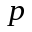 is the total number of inert gases in the mixture
Example Mixture: 9%(O₂) + 16%(N₂O) + 75%(He)
Calculation steps
Step 1: Ascertain the coefficient of oxygen equivalency (Ci) for the oxidising gases in the mixture and the nitrogen equivalency factors (K_{k}) for the non-flammable, non-oxidising gases.
Ci (N₂O) = 0.6 (nitrous oxide)
Ci (O₂) = 1 (oxygen)
K_{k} (He) = 1 (helium)
Step 2: Calculate the Oxidising Power of the gas mixture
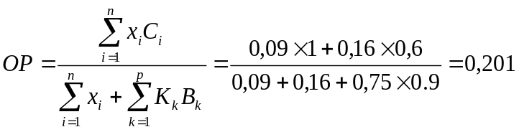 20.1 < 23.5
Therefore the mixture is not considered as an oxidising gas.".

